**Individual Project 1 Screenshots**

**Workflow Screenshot:**

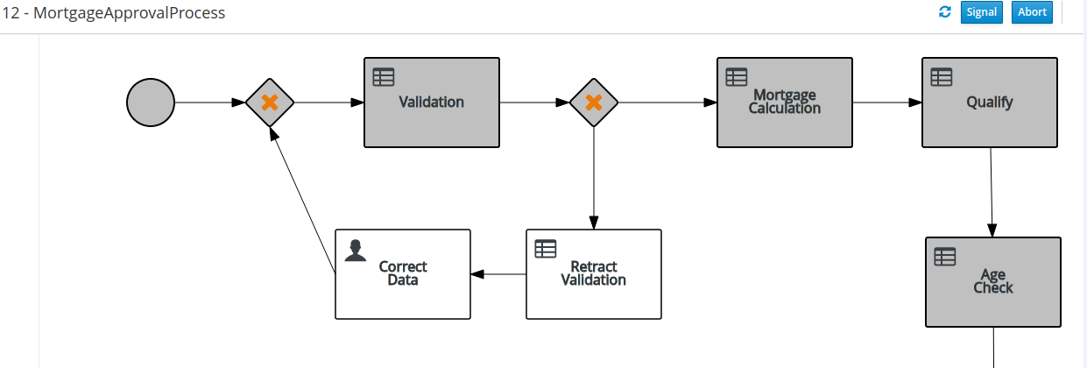

**Logic:**

**Qualifying Automation**

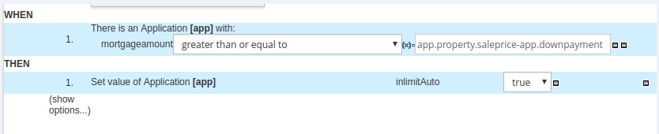

**Age Checking**

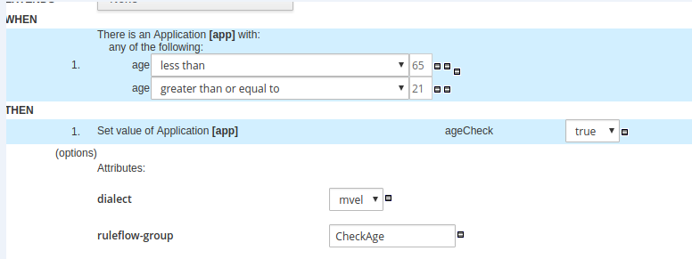

**Sample Inputs:**

Applicant Age:35

Applicant Annual Income: 10,100

How old is the house: 5

Sale price: 11,000

Down payment: 10,000

**Expected Outcomes:**

Mortgage Amount is 50,000



Applicant’s age is <65 and >= 21 years old



The mortgage amount is more than the price of the house – down payment.

